TREATING IRON

MAGNA-Tec Standard Rack Set

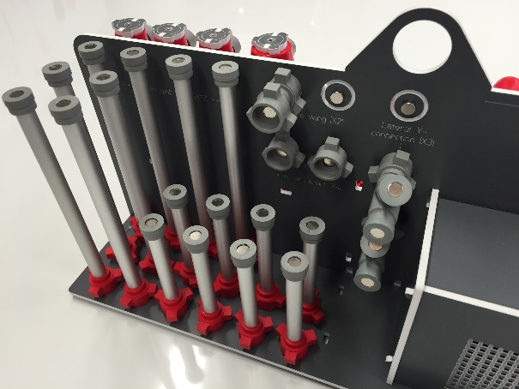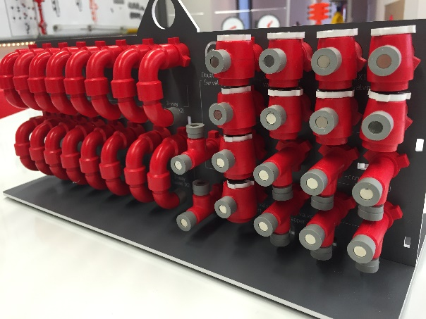

EQUIPMENT SET CONTENT LIST & ORDER

Item | Description | Qty. | Image | Comment
 | Swivel, 2-way, 1502 | 10 | 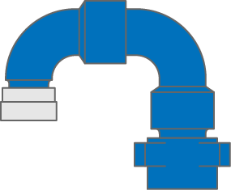
 | Swivel, 3-way, 1502 | 4 | 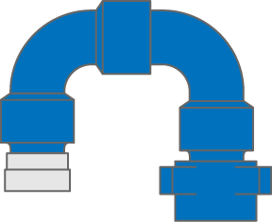
 | Swivel, 3-way, double-wing, 1502 | 2 | 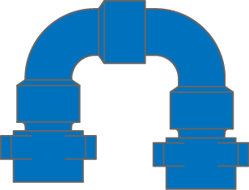
 | Valve, 2x2, 1502 | 6 | 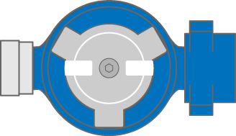
 | Valve, 2x2, 1502 | 4 | 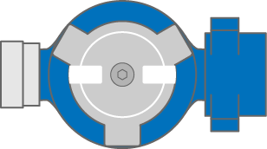
 | T-connection, 1502 | 4 | 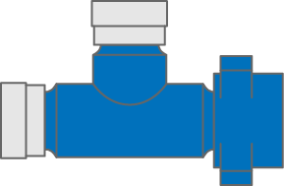
 | Lateral Y-connection, 1502 | 3 | 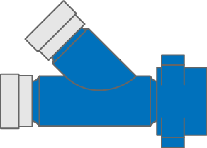
 | Iron joint, long, 1502 | 12 | 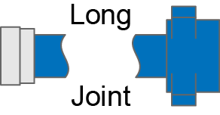
 | Iron joint, short, 1502 | 4
 | Check valve, dart, 1502 | 1 | 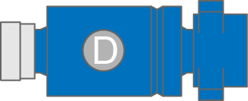
 | Check valve, flapper, 1502 | 1 | 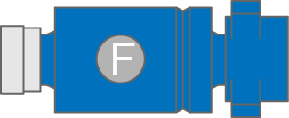
 | Fixed Choke | 1 | 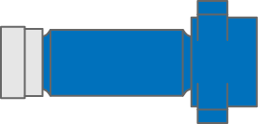
 | Double wing, 1502 | 2
 | Double thread, 1502 | 2
 | Pressure Sensor | 2 | 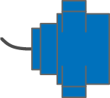
 | Rack | 1 | As Shown Above

TREATING IRON
Supplementary Options
Available Colours

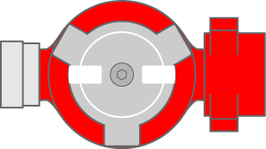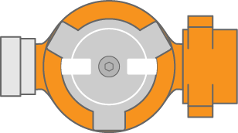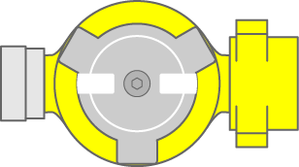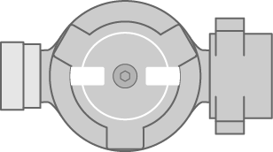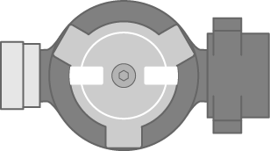
Blue Red Orange Yellow Grey Black

Item | Description | Image | Qty. | Comment
2-in. Treating Iron

 | 2x2 Plug Valve, Flanged | 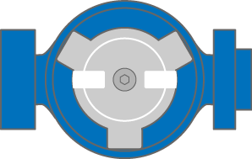
 | 2x2 Plug Valve, Half-flanged | 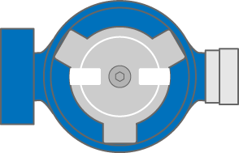
 | Pressure Relief Valve | 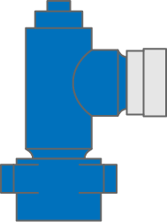
 | Elbow, 90-degrees, Flowback | 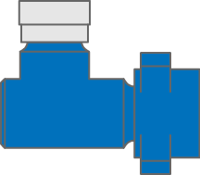
 | Swept Elbow, 90-degrees | 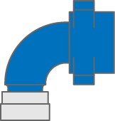
 | T-connection, WTW | 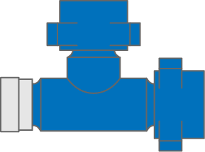
 | Flow Cross, TTTW | 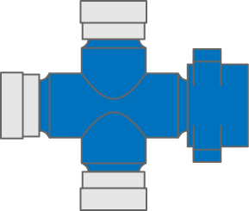
 | Adjustable Choke | 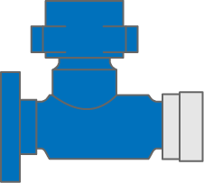
 | Densitometer | 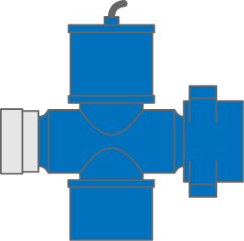
 | Bull Plug
 | Adaptor, Flange x 2-in. Wing
 | Adaptor, Flange x 2-in. Thread
 | Adaptor, 3-in. T x 2-in. W | 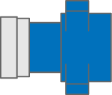
 | Adaptor, 2-in. T x 3-in. W | 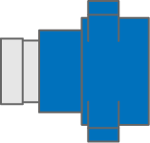
3-in. Treating Iron

 | 3-in. 2-way Swivel
 | 3-in. 3-way Swivel
 | 3-in. Plug Valve
 | 3-in. T-connection
 | 3-in. Lateral Y-connection
 | 3-in. Long Joint
 | 3-in. Short Joint
 | 3-in. Bull Plug
 | 3-in. Double Wing
 | 3-in Double Thread
 | 3-in. Densitometer
 | 3-in. H-manifold | 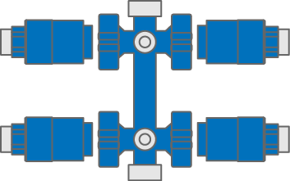
 | 3-in. Check Valve
 | 3-in. GORV | 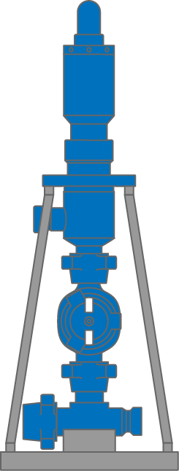
 | 3-in. Frac Header | 