Management of Major Emergency (MoME)
Offshore Standard Set List & Order

Rev E – November 2015

Item | Description | Image | Quantity | Comment
Roles & Personnel

 | On Scene Commander | 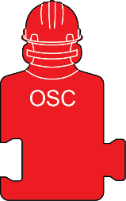 | 2
 | Fire Team 1 | 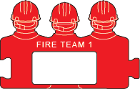 | 2
 | Fire Team 2 | 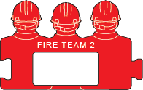 | 2
 | Fire Team 2 | 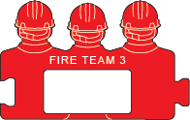 | 2
 | Medic | 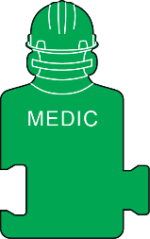 | 2
 | First Aid Team | 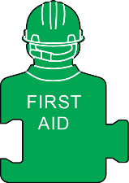 | 9
 | Stretcher Party Member | 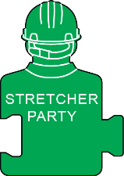 | 6
 | Stretcher Casualty | 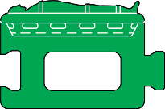 | 2
 | Walking Casualty | 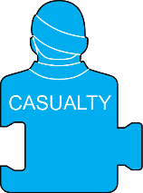 | 18
 | Helicopter Landing Officer | 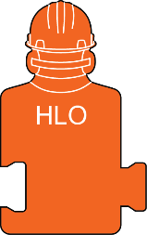 | 2
 | Helideck Assistant | 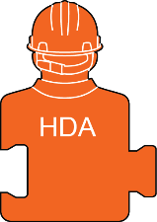 | 6
 | Blank – with radio | 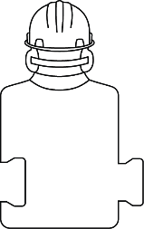 | 6
 | Blank – without radio | 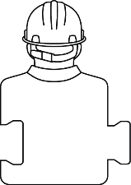 | 6
Vessels & Equipment

 | Fast rescue craft |  | 1
 | Standby Boat |  | 1
 | Supply Boat | 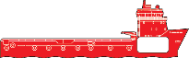 | 2
 | Coast Guard Helicopter |  | 2
 | Crew Change Helicopter |  | 1
Hazards & Environmental

 | Fire | 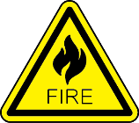 | 9
 | Smoke | 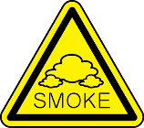 | 9
 | Gas | 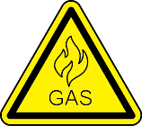 | 9
 | Blast | 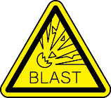 | 6
 | Oil Spill | 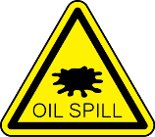 | 9
 | H2S Gas | 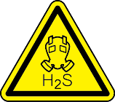 | 6
 | Sprinkler | 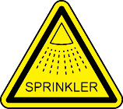 | 6
 | Deluge | 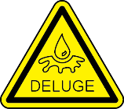 | 6
Case & Storage

 | Case with profiled foam insert for Offshore Standard Set | 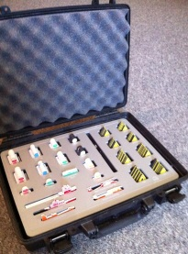

Management of Major Emergency (MoME) Offshore Set
Supplementary Options

Rev E – November 2015

Item | Description | Image | Quantity | Comment
Roles & Personnel

 | On Scene Commander,  Full text option | 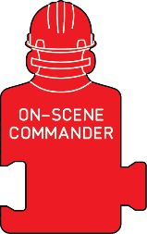
 | Fire Team Leader, FTL | 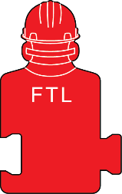
 | Fire Team Leader,  Full text option | 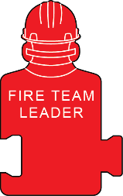
 | Fire Team 1,  Single man | 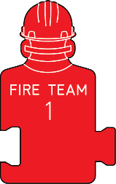
 | Fire Team 2,  Single man | 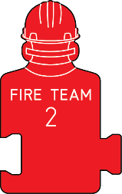
 | Fire Team 3,  Single man | 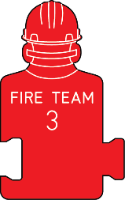
 | Emergency Response Team Leader | 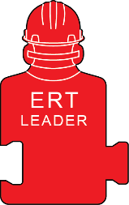
 | Emergency Response Team 1 | 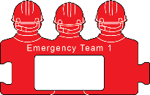
 | Emergency Response Team 2 | 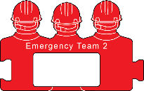
 | Safety Advisor | 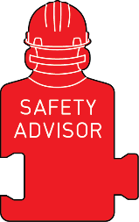
 | Support Team, Pair | 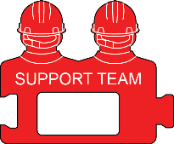
 | Support Team, Single | 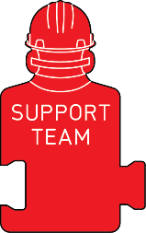
 | Walking Casualty, Numbered | 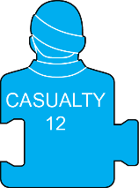
 | Walking Casualty, Group
 | Stretcher Casualty, Blue | 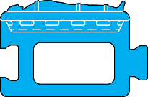
 | First Aid Team, Pair | 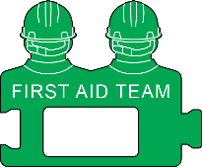
 | Triage Team | 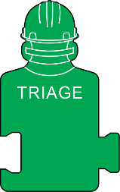
 | Man Overboard, Coxswain | 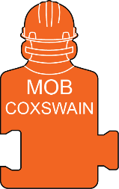
 | Man Overboard Team | 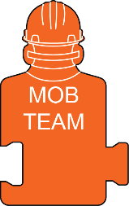
 | Pilot | 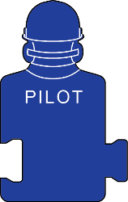
 | Technical Team, Pair | 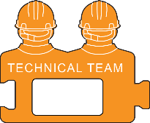
 | Technical Team, Single | 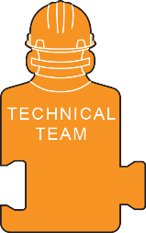
 | Rigging Team, Pair | 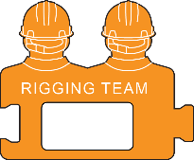
 | Rigging team, Single | 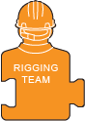
 | Scaffold Team, Pair | 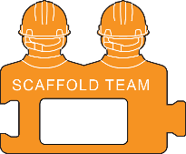
 | Scaffold Team, Single
 | Diver | 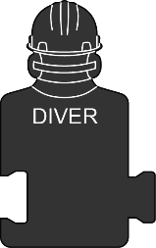
 | Driller | 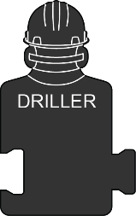
 | Crane Operator | 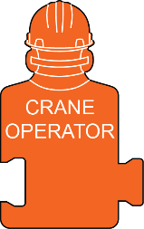
 | Banksman
 | Contractor
Vessels & Equipment

 | Lifeboat
 | Liferaft
 | Daughter Craft
 | Anchor Handling Vessel | 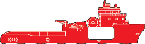
 | Dive Support Vessel | 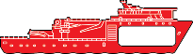
 | Supply Boat, Black
 | Infield Helicopter | 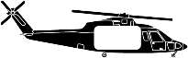
 | Crew Change Helicopter, Black | 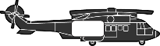
 | Crew Change Helicopter, Blue
 | Rack-Up Rig | 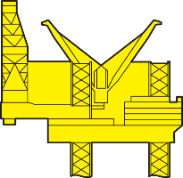
 | Semi-submersible | 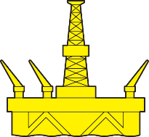
 | Platform | 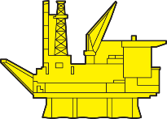
Hazards & Environment

 | Blast, Red | 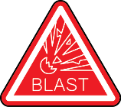
 | Chemical Spill, Brown | 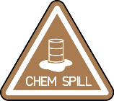
 | Chemical Spill, Green | 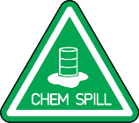
 | Chemicals | 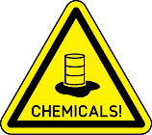
 | CO₂ | 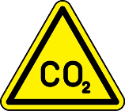
 | Deluge, Blue | 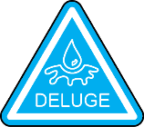
 | Fire, Red | 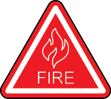
 | Fire Monitor | 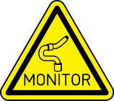
 | Fire Monitor, Red | 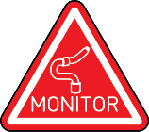
 | Foam | 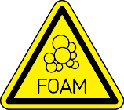
 | Foam, Blue | 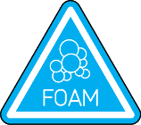
 | Gas, grey | 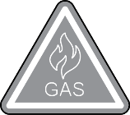
 | H₂S, Brown | 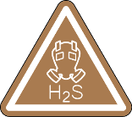
 | H₂S, Green | 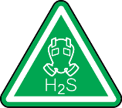
 | High Voltage | 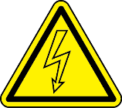
 | Oil Spill, Brown | 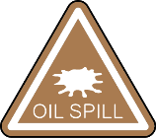
 | Oil Spill, Green | 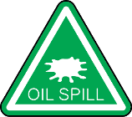
 | Radiation | 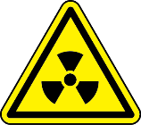
 | Smoke, Grey | 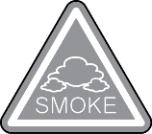
 | Sprinkler, Blue | 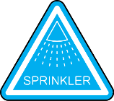
 | Stability | 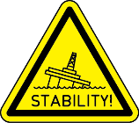
 | Stability, Red | 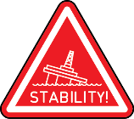
 | Toxic Chemicals | 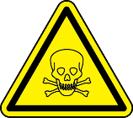
 | Water Mist, Blue | 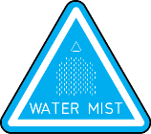
Misc. Signs & Markers

 | Wind Direction, MPH | 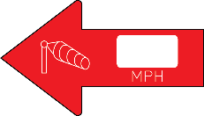
 | Wind Direction, Bauf. | 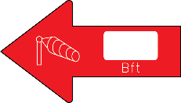
 | Wind Direction, MPH, White | 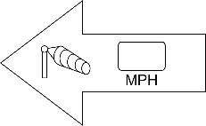
 | Current Direction, Blue
 | Forward Control Point | 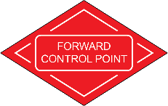
 | Triage Point | 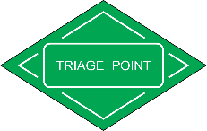
 | Winch Zone | 